**TUẦN 15: BÀI TẬP DẠY ONLINE**

Trường THCS Hoàng Lê Kha THEME 8: PLACES Grade 7

Week 15 - Period: 29, 30 LESSON 1: Asking the way ( A1,A3)

Date: 13/12 – 18/12 LESSON 2: At the post office ( B1)

**EXERCISES**

**I. Name the places.**

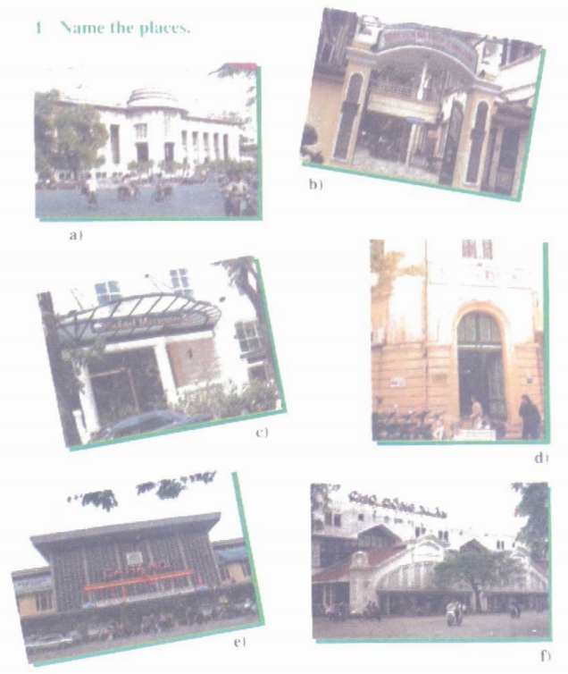

**a) …………………………………………………………………………………….**

**b) …………………………………………………………………………………….**

**c) …………………………………………………………………………………….**

**d) …………………………………………………………………………………….**

**e) …………………………………………………………………………………….**

**f) …………………………………………………………………………………….**

**II. Look at this street map. Practice the dialogue with a partner.**

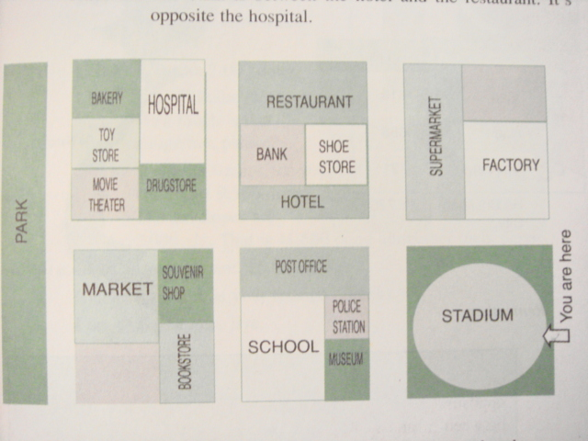

Example:

Nga: Where is the bank?

Nam: The bank is between the hotel and the restaurant. It’s opposite the hospital.

**\* Ask for and give directions to these places.**

|  |
| --- |
| bank              restaurant police station   hotel  shoe store       post office bookstore        school |

**III. Listen and read. Then practice with a partner.**

**Liz:** Excuse me. I d like to send this letter to the USA. How much is it?

**Clerk:**It's 9,500 dong.

**Liz:** And I need some envelopes. How much are those?

**Clerk:** They are 2,000 dong.

**Liz:** OK. I’ll take them. How much is that altogether, please?

**Clerk:** Well, the stamps for your letter cost 9,500 dong. The envelopes are 2,000...That is 11,500 dong altogether then, please.

**Liz:** Here you are. 15,000 dong.

**Clerk:**And here is your change. Thanks.

**Liz:** Thank you. Bye.

**Now answer the questions.**

a) Where will Liz mail her letter?

=> ………………………………………………………………………………………………

b) How much does Liz pay altogether?

=> ………………………………………………………………………………………………

c) How much change does she receive?

=> ………………………………………………………………………………………………

**IV. Choose the best word or phrase ( A, B,C or D) that best fits each blank space:**

1. Excuse me? Is there a post office _________ here?

A. near B. on C. in D. at

2. __________ you tell me the way to the railway station?

A. Could B. Do C. Are D. Should

3. How __________ is it from here to the nearest post office?

A. far B. away C. long D. much

4. ___________ are these stamps? – Five thousand dong.

A. How much B. How many C. How D. How long

5. These stamps ________ cheaper than those one.

A. costs B. is C. cost D. have

6. He phones his parents ________ a week.

A. two B. two times C. second D. twice

7. Her pens cost 40,000 dong, and she gives 100,000 dong. How much _________ does she receive?

A. money B. cost C. charge D. chang

8. ________ the second street on the left. The bank is _____ your right.

A. Take – in B. Go – on C. Take – on D. Go – in

9. The bank is ________ the hotel and the post office.

A. opposite B. next C. on D. between

10. The post office is ________ of my school.

A. opposite B. in front C. beside D. next

11. The bookstore is _______ to the hotel.

A. next B. near C. far D. opposite

12. I need to buy a phone _______. I phone my parents once a week.

A. call B. card C. line D. stamp

13. Excuse me? I _________ like to send this letter to the USA. How ____ is it?

A. would – many B. will – much C. will – many D. would – much

14. I need three stamps, five envelopes and a writing pad. How much is that ________?

A. at all B. together C. altogether D. in together

15. I phone _________ my pen pal once a week.

A. to B. with C. from D. at

16. It takes you about 15 minutes ________ to the Central Post Office by bus.

A. get B. to get C. getting D. to getting

17. Her parents work hard ________ their farm.

A- in B- on C- up D- at

18**.** Thuy has her English class______ 8.30 a.m­­­­­­.

A. to B. at C. on D. for

19**.** “Let’s have some music .” - “________________”

A. Yes, I like B. No, we don’t C. Sorry, I can’t D. Good idea

20. Not many students are interested_________ grammar.

A. on B. about C. to D.in

**V. Rewrite each of the following sentences in another way so that it means almost the same as the sentence printed before it:**

21. The souvenir shop is on the left of the hotel.

→ The hotel is on the

22. I often walk from my house to school in ten minutes.

→ It takes me

23. Let’s skip rope at recess.

→ How about_______________________________________________________?

24. How much is this book?

→ How much does ?

25. I get to school in half an hour.

→ It takes

26. The library contains over 30 million books.

→ There______________________________________________________________________

27. Let’s go in and get the things you need.

→ What about ?

28. Let’s skip rope at recess.

→ How about_______________________________________________________?

29. My father has more days off than my mother.  
 → My mother

30. What about playing blindman’s bluff or catch ?

→ Let’s .

**VI. Read then answer TRUE or FALSE**

Vietnamese students have fewer vacations than American students. Each year, we just have about four vacations. We have a day off for Independent Day on September 2nd , two days off on April 30th and May Day. Our longest vacation is summer vacation. It lasts for almost three months. We usually spend time with our families. We don’t have vacations for Easter, Thanksgiving and Christmas, but we also celebrate them.

31.American students have more vacations than Vietnamese students. ______

32. The longest vacation of Vietnamese students isn’t summer vacation. ______

1. On September 2nd , Vietnamese students have a day off. ______
2. American students don’t have vacations for Easter, Thanksgiving and Christmas. ______